

PHP PROJECT USER GUIDE

Online Movie Booking System

**(Batch: 2010B3)**

19.05.2022

**─**

|  |  |
| --- | --- |
| Student1278398 | MUHAMMAD IRFAN . |
| Student1278149 | MUHAMMAD JUNAID GHANI |
| Student1274232 | HAMZA SIDDIQUI |
| Student1204067 | WAHAJ BIN AHMED |

**PROJECT** **SUBMITTED BY**

**Project Instructor Miss Hina Siddiqui**

**Batch Code 2010B3**

# 

SCREEN SHOTS OF

Online Movie Booking System

# Home Page:

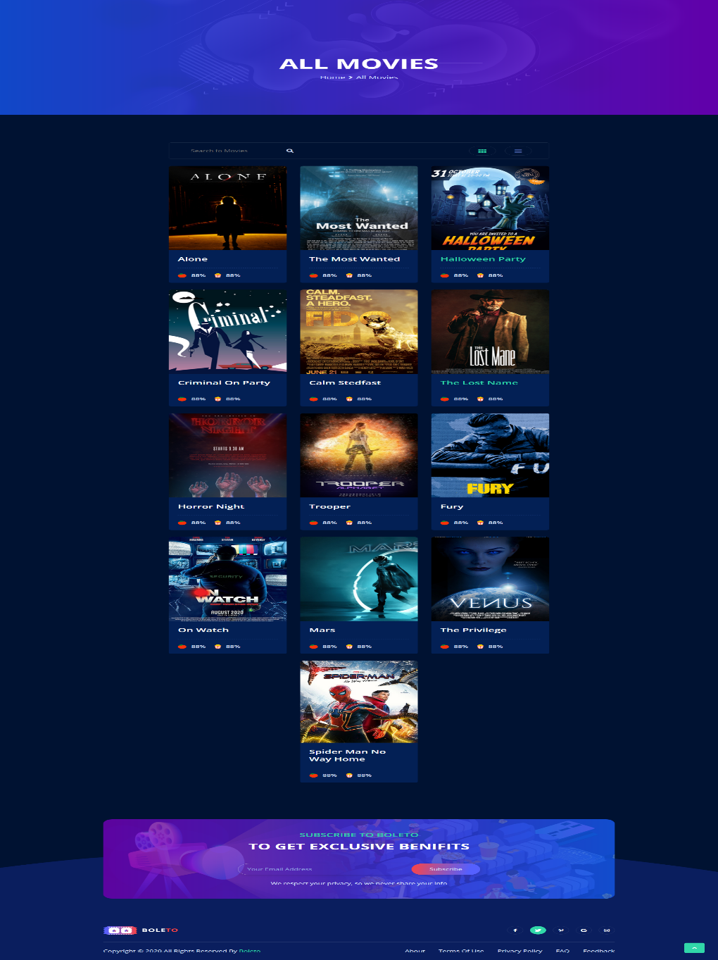

# About Page:

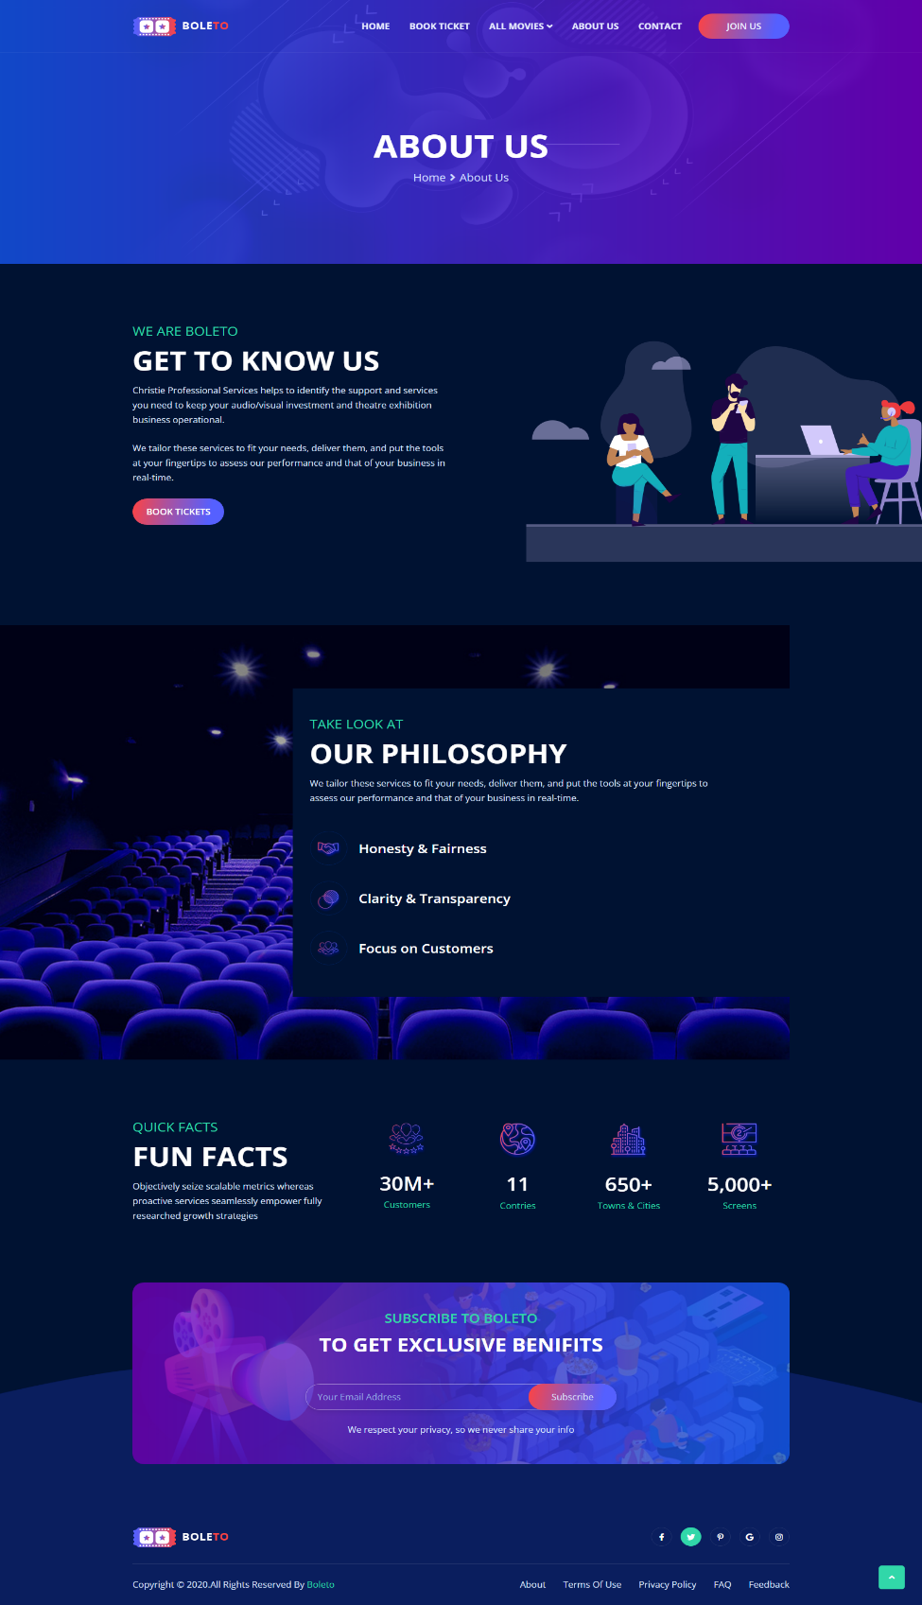

# Contact Us Page:

This Is Contact page User Can Contact Admin by Composing Mail



# Signup Page:

# Login Page:

# Booking Ticket:

# 

# Booking Ticket:

Database of PHP Project:

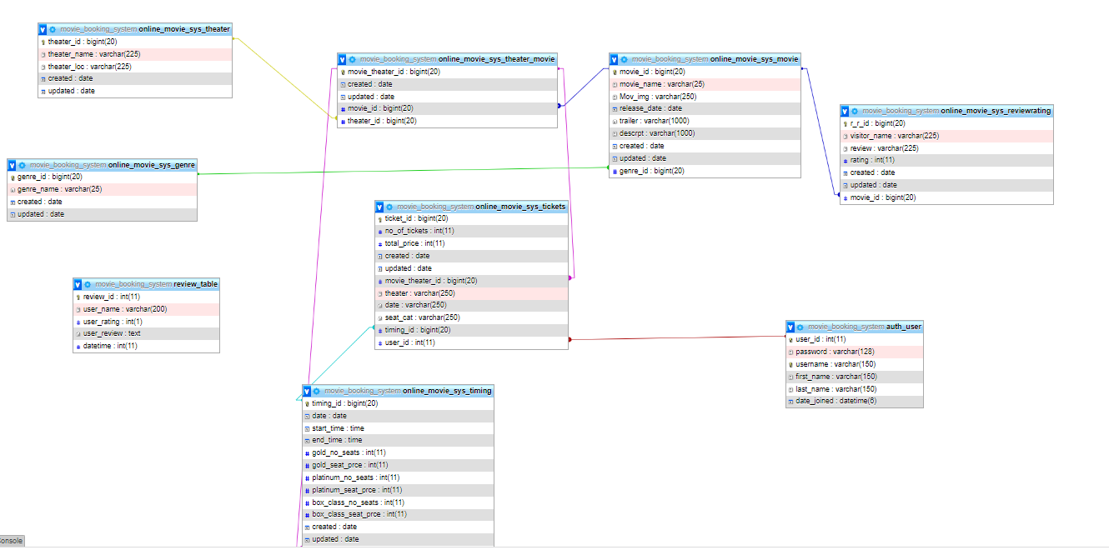

# THE END ….